 **Statement and Confirmation of Own Work**

|  |  |
| --- | --- |
| ***Each time you submit an assignment you must attach this statement as the cover page for both the hard copy and the electronic version. If the statement is missing your work will not be marked.*** | |
| **Student Declaration** | |
| I have read and understood NCC Education’s Policy on Academic Dishonesty and Plagiarism.  I can confirm the following details: | |
| Programme/Qualification Name: | LEVEL 4 DC |
| Student ID/Registration number: | L4DC/94/205660 |
| Name: | YAMIKANI MACHONJO |
| Centre Name: | NACIT (BLANTYRE) |
| Module Name: | Designing and Developing a Website |
| Module Leader: | Mrs C. FUNSANI |
| Number of words: | 1054 |
| I confirm that this is my own work and that I have not plagiarized any part of it. I have also noted the assessment criteria and pass mark for assignments. | |
| Due Date: | 18 JANUARY 2024 |
| Student Signature: |  |
| Submitted Date: | 18 JANUARY 2024 |

Contents

TASK 3 3

Introduction 3

W3C VALIDATION 3

TEST FOR ACCESSIBILITY 4

How the website works for disabled people 4

DIFFERENCES IN WEB BROWSERS AND DISCREPACIES 4

Rectifying 5

THE ROLE OF W3C 5

TASK 4 5

CRITICAL EVALUATION 5

Introduction 5

Body 5

Suitability of tools 5

Intuitive interfaces 6

Accessibility feature 6

Improvements 6

# TASK 3

## Introduction

The purpose of the website is to share information about different standing desks available. Customers will be able to order different standing desks from the websites and discover different health benefits of these desks.

## W3C VALIDATION

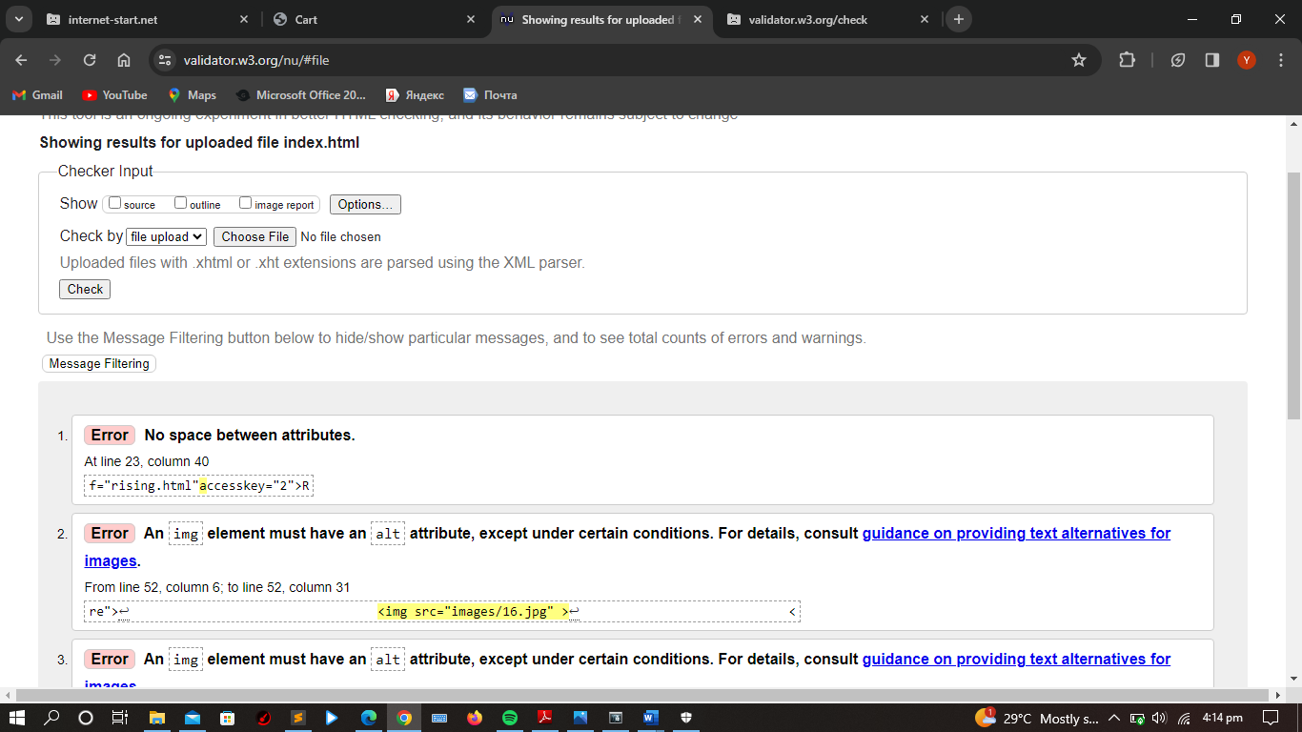

The figure above shows errors after the first test for validation on W3C validator website on index page

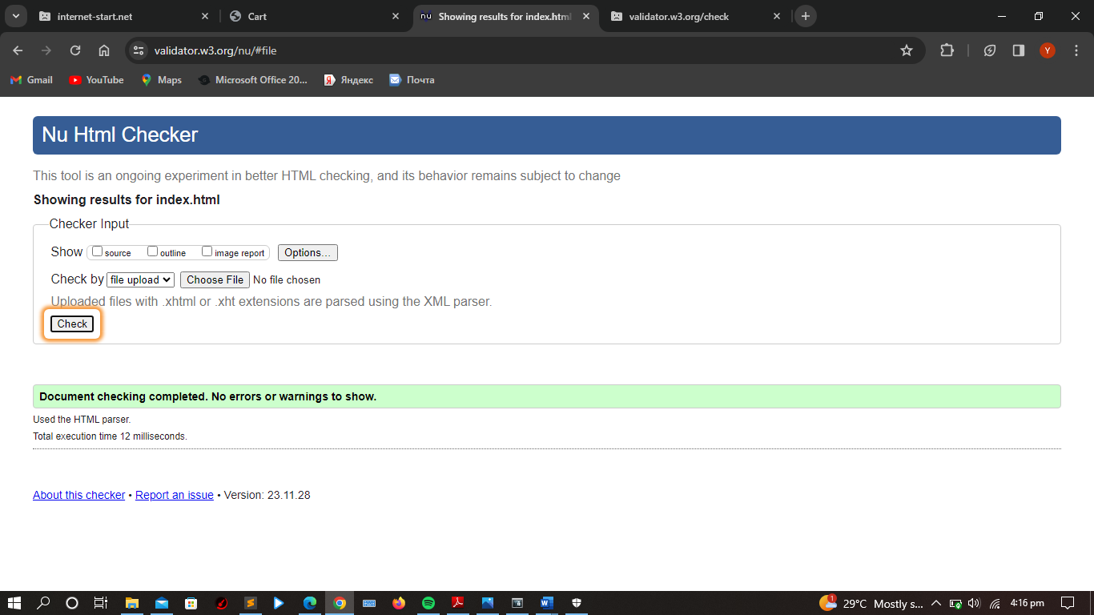

The figure shows results after fixing the errors above

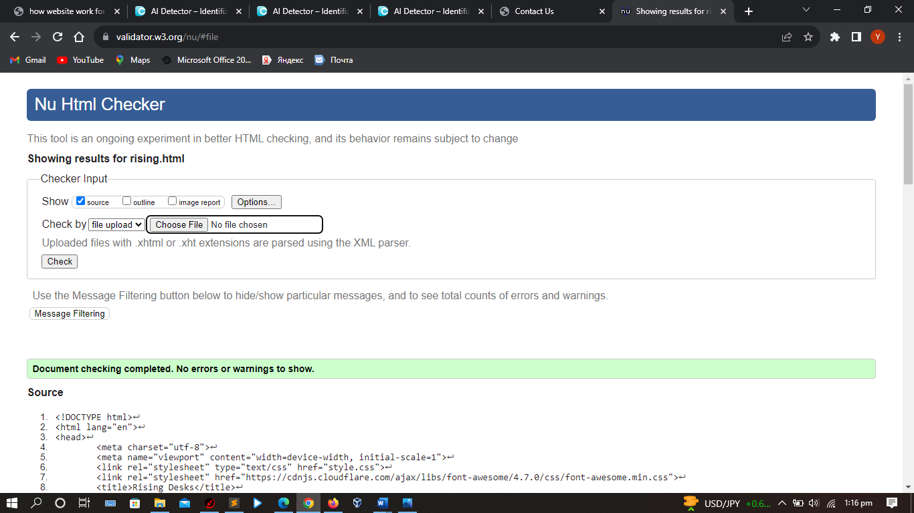

Health page had no errors

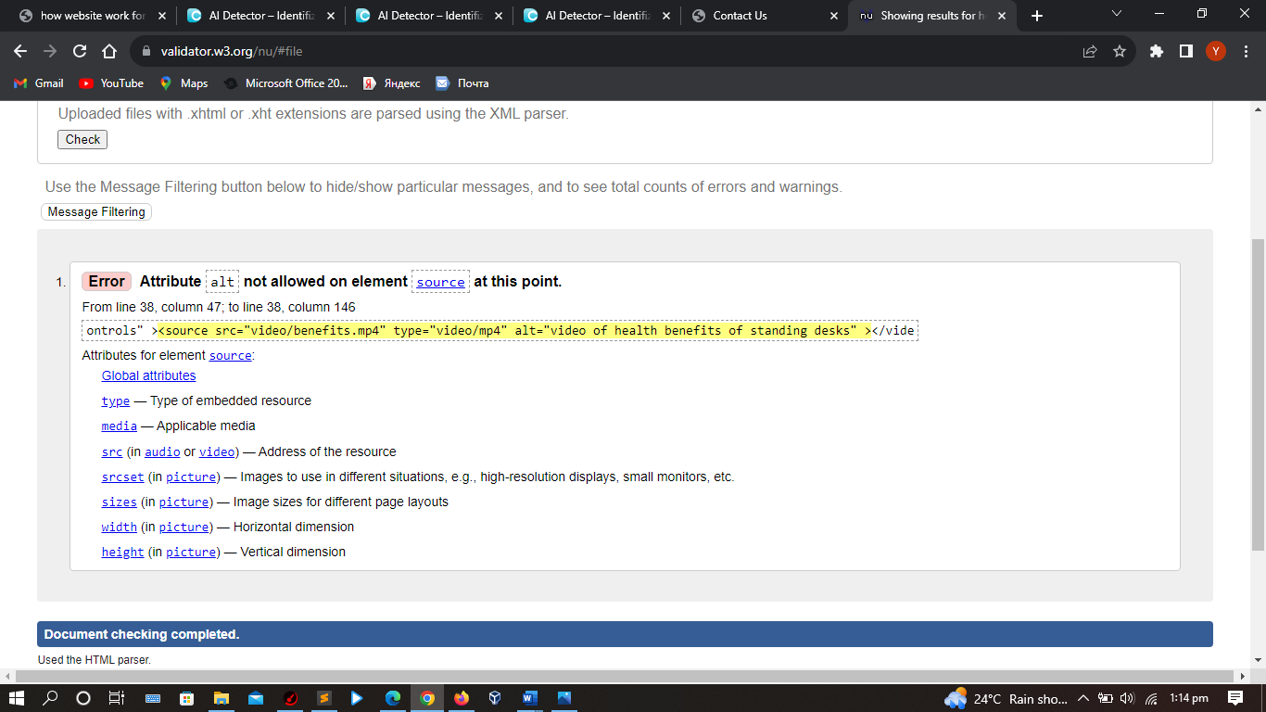

The above error was found in the health benefits page after testing it for the first time.

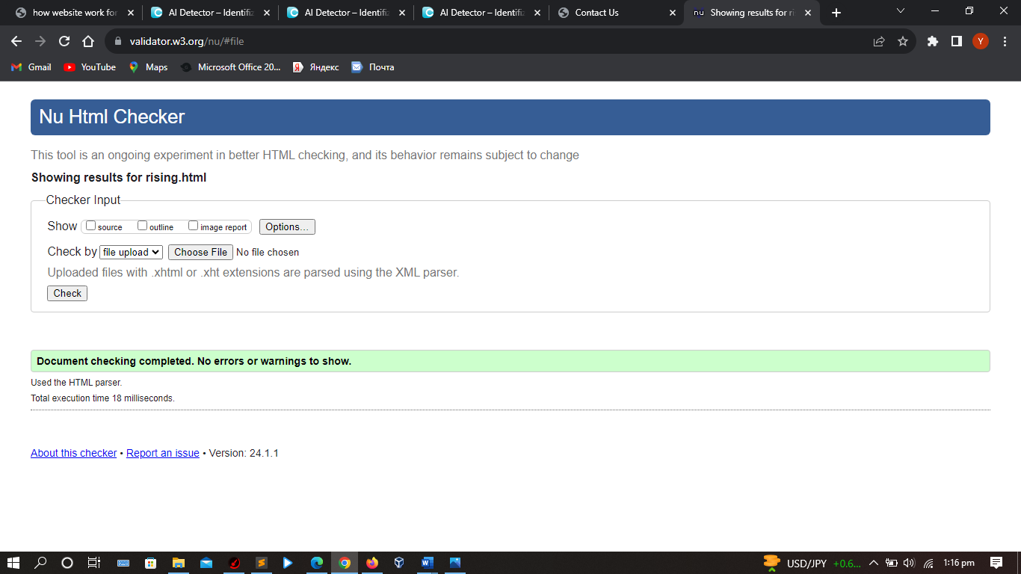

The error was then fixed as shown above.

CSS was also validated; errors were also found as shown below

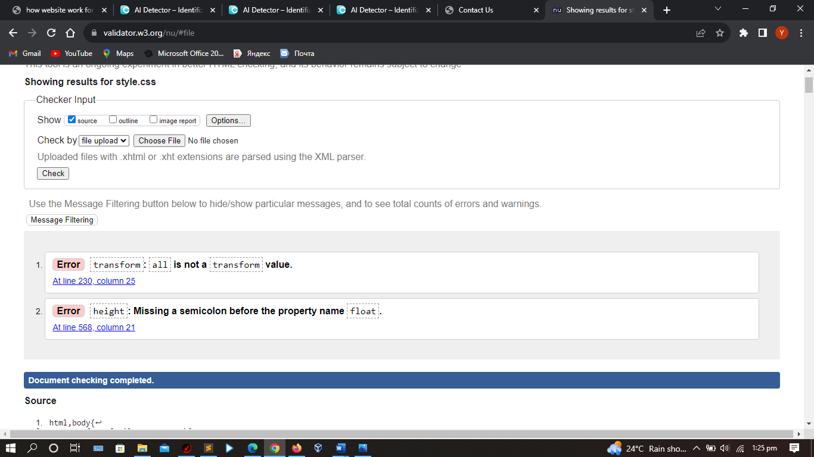

The errors were rectified and the file was validated again the results are as below

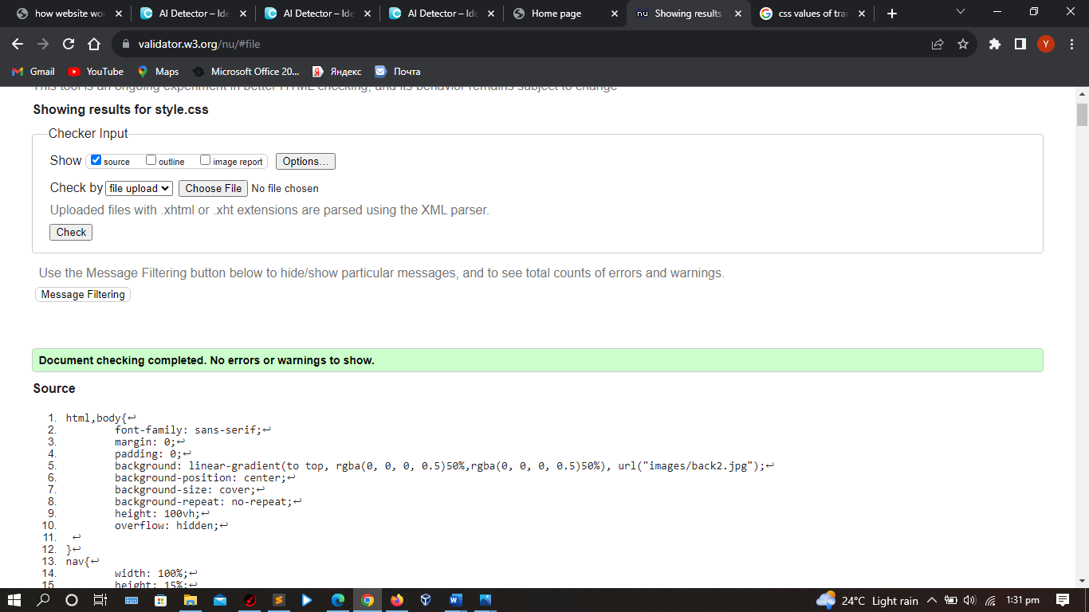

## TEST FOR ACCESSIBILITY

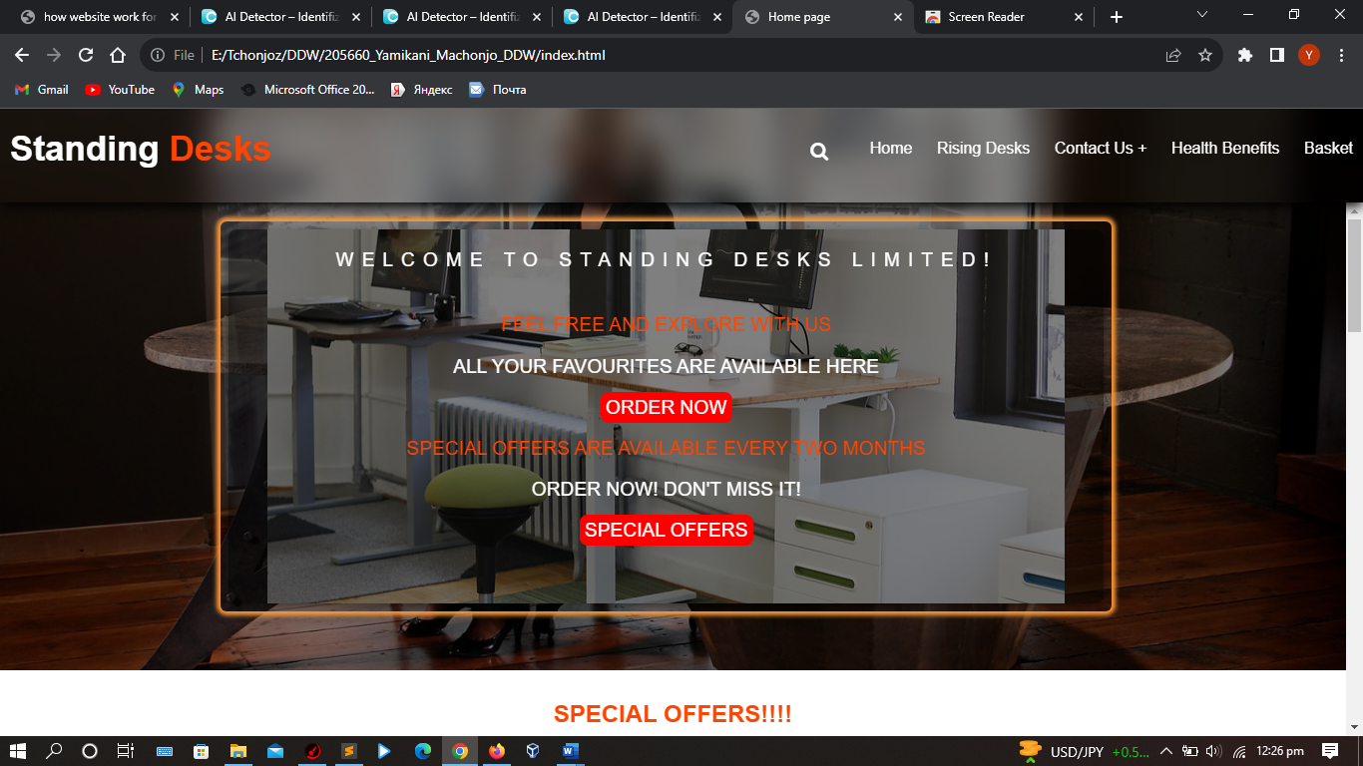

The website was tested for accessibility using chromeVox screen reader. Almost all the features of the website were accessible like the text and the images were accessible. The one video in the website was not accessible even after putting the alternative text. This problem was not resolved.

## How the website works for disabled people

The website is accessible to different people with disabilities. People with motor challenges can access the pages using different access keys available in the website. People with visual impairment can access the website using different screen readers as all the images have alternative text.

## DIFFERENCES IN WEB BROWSERS AND DISCREPACIES

* There were not many differences. The first difference is in chrome the module pop up came on the top middle part of the page while in firefox the pop up came right at the center of the page.

Below is a pop up in firefox:

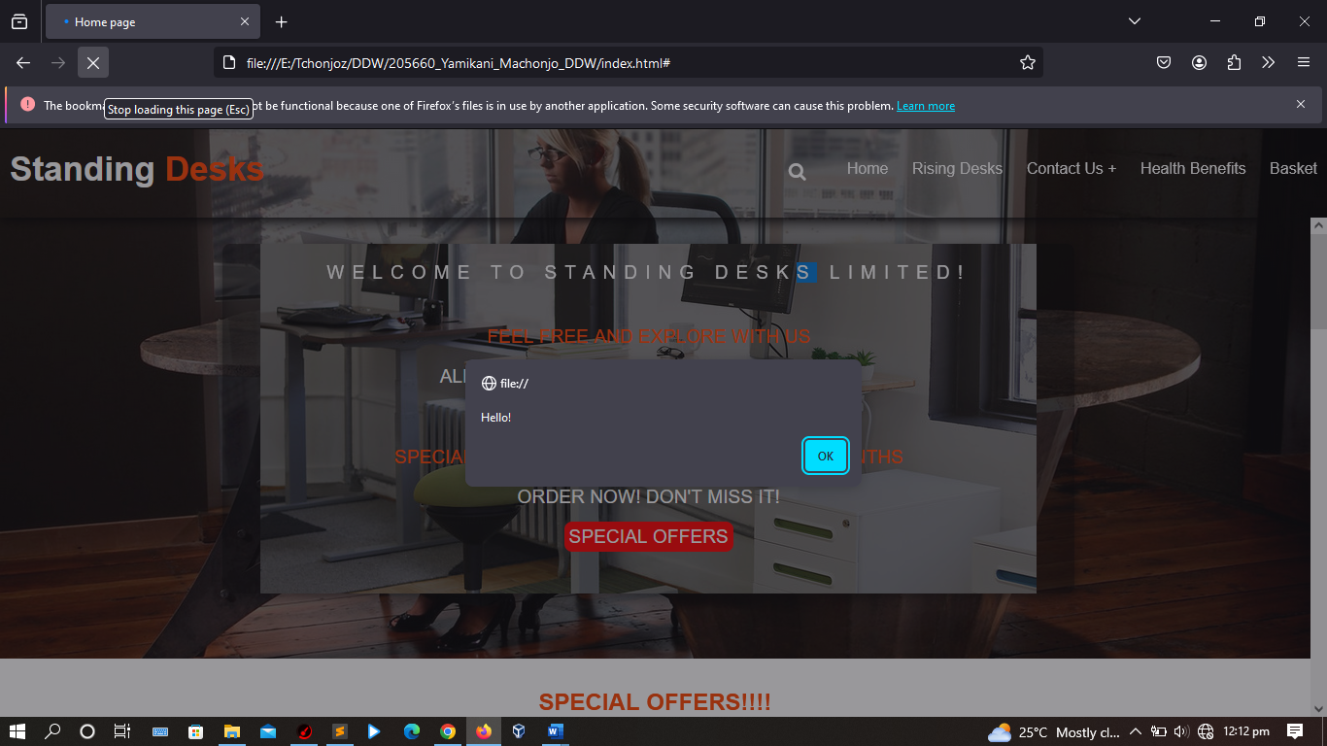

Below is a pop up in chrome:

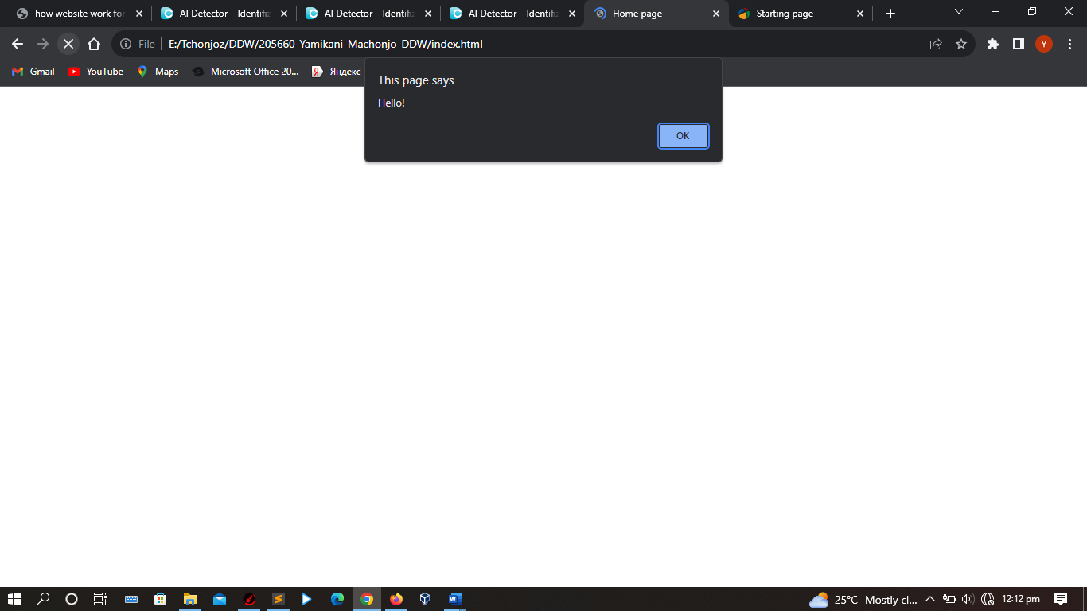

* In the code there is a blur feature in the website but chrome is the only browser rendering that other than firefox, in firefox it’s just transparent as shown below.

Below is home page in chrome:

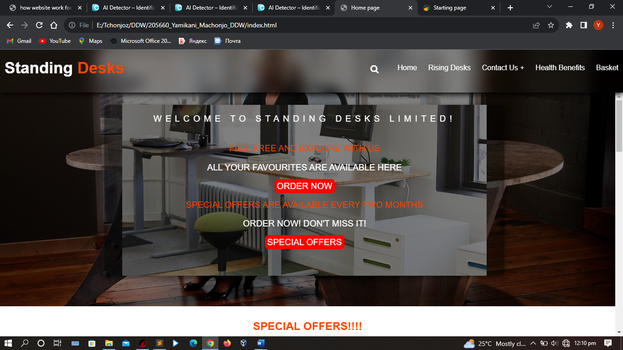

Below is a home page in firefox: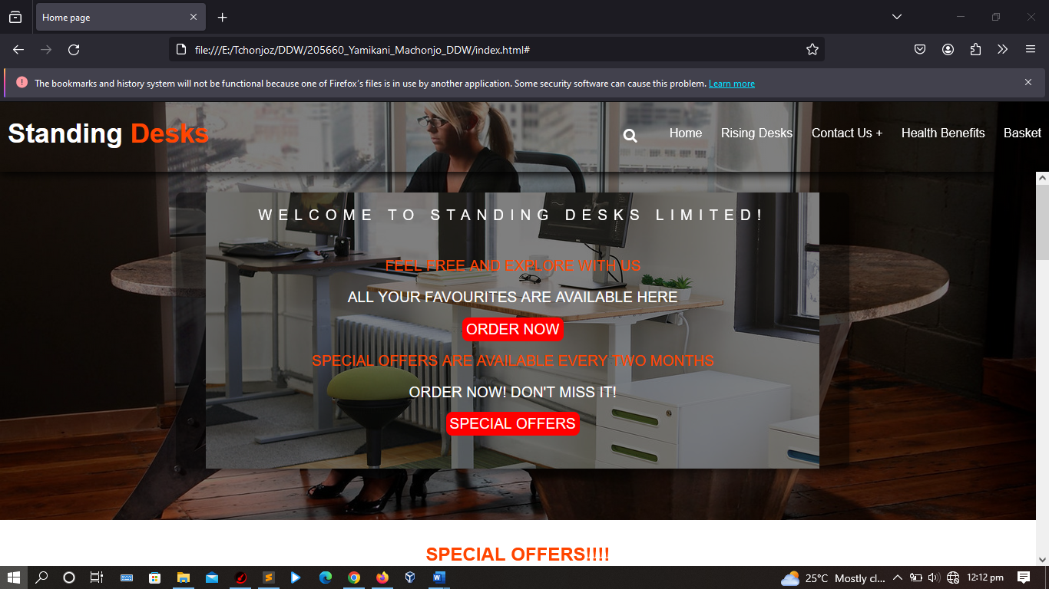

Reasons

* The reason for this is because firefox might not support the blur feature other than other tested website like chrome and Microsoft edge.

Test discrepancies

Problem

* In the code there is a blur feature in the website but chrome is the only browser rendering that other than firefox, in firefox it’s just transparent.

Reasons

* The video was unable to be read by the screen reader in all browsers

## Rectifying

* The blur effect problem was unable to be rectified
* The recommendation is to try and use alternative browsers
* The video still was unable to be read by the screen reader even after putting alternative text.

## THE ROLE OF W3C

* It is to make sure all websites do not breach the web standards so that they can works on different devices without any problems

# TASK 4

# CRITICAL EVALUATION

## Introduction

This report is to evaluate what exactly is in the website

## Body

## Suitability of tools

The website was developed using a software called Sublime text. This is a text editor to write html, css and javascript code to render it in the browser.

The website was developed using frontend technologies. These technologies are HTML, CSS and Javascript.

HTML was used to structure the website. Putting all necessary tags in their designated places and specifying parts of the pages.

CSS was used to style the format of the HTML structure. It is also able to group elements together, position them and sometimes the behavior of elements like animations.

Browsers, chrome and firefox were used to test the website. The website was checked for errors on w3c validator and checked for accessibility using chrome screen reader chromevox

In html the company name and the navigation links were all nested in the nav tag. And them css was added to make that a header with the company name on the other side and the navigation links on the other side.

A div was then added to carry all the content of the website. The div was targeted using css to make sure everything aligns with the header, that there should not be any distortion of the website. A nesting technique was used to nest different elements. Inside the content div, another div was added to carry the welcoming remarks of the

Website.

A div with a class attribute was also nested inside the content div to carry all the available offers of standing desks. There were no position properties for the layout design.

## b. Intuitive interfaces

* In many cases, the efficiency is less important than how satisfied the users are while they are experiencing the product (Hussain, et al., 2018).
* Users surf on the web effectively and easily on the website. This is so because in intuitive websites, task must be completed in a minimum number of steps.
* Intuitive designs must be consistent or uniform. One should not change colors of the header, buttons or background color (Mobasseri, 2023).
* An intuitive design should also be visible. Important elements of the website should be easily visible for users to trace them as quickly as possible (Kennedy, 2023).
* An intuitive design also means a user-centered design. This means that a developer should involve the users in all the processes of developing a website from designing to usability testing (Kennedy, 2023).
* The navigation is supposed to be clear and well labelled. People should clearly see that this is navigation. They should easily surf around the website (Mobasseri, 2023).
* Intuitive websites should be accessible. It should prioritize users with disabilities. It should not leave them out

## c. Accessibility feature

* The website has accesskeys to help navigate around the website for motor disability users as shown below:

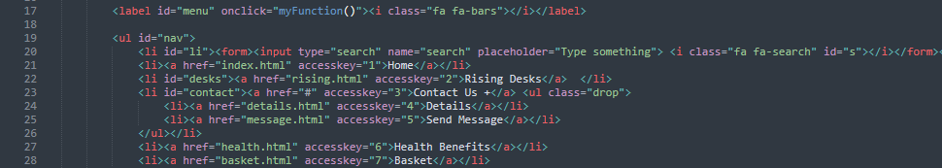

* It also has alternative text in the images which screen readers are able to read as shown below:

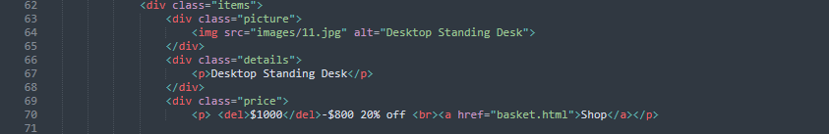

## d. Improvements

* Adding a registration form, where customers will register and be able to login the website.
* Developing an admin site website with a database where they will keep track of all their customers and orders easily. This will be done using PHP
* Customers will be able to know throw their accounts if their order has been confirmed or not.
* Creating an active blog that will allow the customers to be informed abot new products.
* Improve some of the feature with different content management systems like wordpress and drupal
* Adding more interaction features with javascript so that customers will interact with the website more and easily

# References

Hussain, J. et al., 2018. J Multimodal User Interfaces. *Model-based adaptive user interface based on context and user,* pp. 1-16.

Kennedy, M., 2023. *medium.* [Online]   
Available at: https://medium.com/@marieckennedy/understanding-the-power-of-intuitive-user-interface-design-81802b93824d  
[Accessed 16 January 2024].

Mobasseri, N., 2023. *bootcamp.uxdesign.cc.* [Online]   
Available at: https://bootcamp.uxdesign.cc/3-key-principles-for-creating-an-intuitive-user-interface-6189a6165134  
[Accessed 16 January 2024].